**Dì Yī Kè Wŏ jiào Xú WénCháng**

|  |  |
| --- | --- |
| Wŏ jiào Xú WénCháng。  Wŏ shì ZhōngGuó rén。  Wŏ huì jiǎng gùshì。  Wŏ huì jiǎng Huā MùLán de gùshì。 | My name is *XU WenChang*.  I am from China.  I am good at story-telling.  I can tell [you] stories about *HUA MuLan*. |

|  |  |  |
| --- | --- | --- |
| Text | **Dì Yī Kè Wŏ jiào Xú WénCháng**  **第一课 我叫徐文长** |  |
|  | Wŏ jiào Xú WénCháng  我叫徐文长。  Wŏ shì ZhōngGuó rén  我是中国人。  Wŏ huì jiǎng gùshì  我会讲故事。  Wŏ huì jiǎng Huā MùLán de gùshì  我会讲花木兰的故事。 |  |

|  |  |  |  |
| --- | --- | --- | --- |
| Anatomy of Scripts | | 说文解字(Shuō Wén Jiĕ Zì) | |
| 我 I or me.  with http://ctext.org/font/jin/6208.gifmeaning weapon to the right. Think about don’t kill ME! |  | 叫[To be] called.  Radical to the left is口 (http://ctext.org/font/jin/53e3.gif), meaning mouth, which is certainly needed when you call somebody. The right part provides the sound. | 文Symbol formed with crossing strokes http://ctext.org/font/jin/6587.gifto be used as (building blocks of) scripts. |
| 是Verb to be. Since there is no form change in Chinese, it can mean am, is, are, or even was, were.  With the sun radical 日 (http://ctext.org/font/jin/65e5.gif) right on top. | | 中 Central or middle.  http://ctext.org/font/jin/4e2d.gif is indicative: the vertical stroke (shù) goes right in the middle of the circle. | 国Country.  With radicals 囗 (wéi, meaning boundary) and玉 (yù, meaning jade). The latter shows 王 (wáng, meaning king) + 、(diǎn, dot). Think about a country has a king with some money in his pocket. |

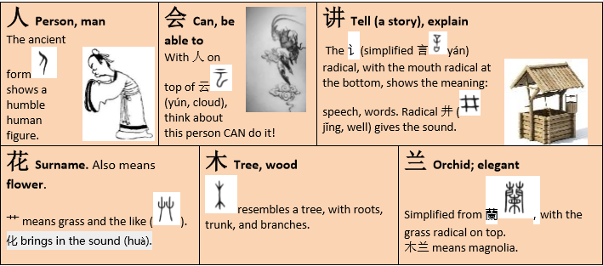

|  |  |  |
| --- | --- | --- |
| Pattern Drills | 句型练习(Jùxíng Liànxí) | |
| 我叫花木兰。  我叫________。(Say your name…)  MíngCháo ZhèJiāng  我是明朝[1]人。我是浙江人。  MĕiGuó  我是美国人。  我是________人。  我会讲美国故事。  HuáShèngDùn  我会讲华盛顿[2]的故事。  我会讲________的故事。 | | http://ctext.org/font/seal/660e.gif = http://ctext.org/font/jin/65e5.gif + http://ctext.org/font/jin/6708.gif  Bright sun moon  http://ctext.org/font/jin/7f8e.gif = http://ctext.org/font/jin/7f8a.gif + http://ctext.org/font/jin/5927.gif  Beautiful lamb big |
| Write the Scripts | 书写练习(Shūxiě Liànxí) | |

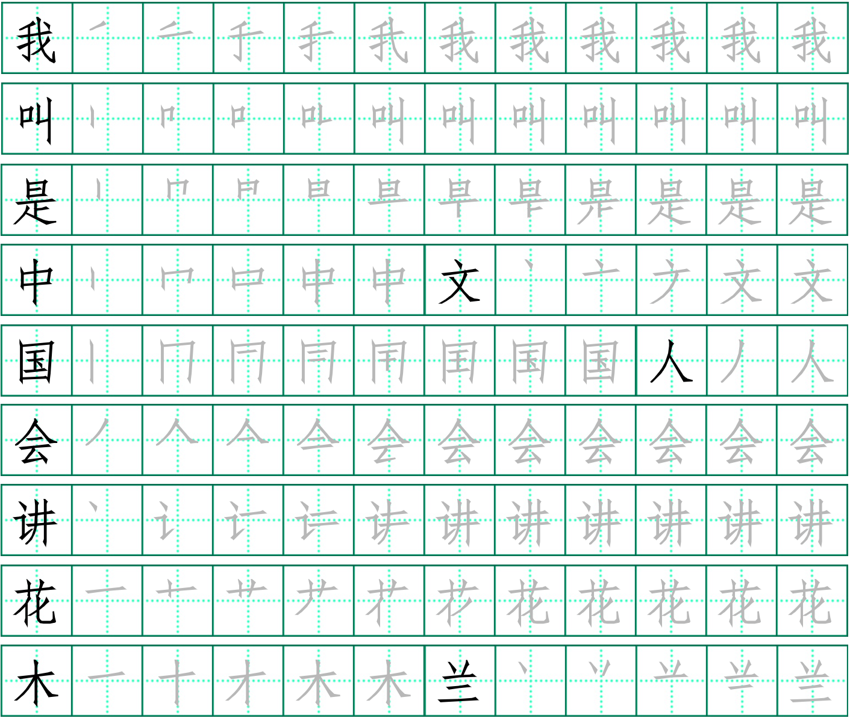

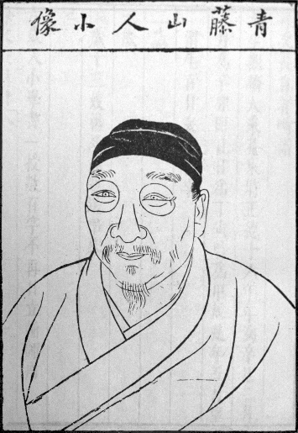

Historical Background

***About Xu WenChang***

**Xu Wei** ([Chinese](https://en.wikipedia.org/wiki/Chinese_language): 徐渭; [pinyin](https://en.wikipedia.org/wiki/Pinyin): *Xú Wèi*; [Wade–Giles](https://en.wikipedia.org/wiki/Wade%E2%80%93Giles): ***Hsü Wei***, 1521–1593) was a [Ming dynasty](https://en.wikipedia.org/wiki/Ming_dynasty) [Chinese painter](https://en.wikipedia.org/wiki/Chinese_painter), poet, writer and dramatist famed for his artistic expressiveness.[[1]](https://en.wikipedia.org/wiki/Xu_Wei#cite_note-Cihai-1)

Revolutionary for its time, his painting style influenced and inspired countless subsequent painters, such as [Bada Shanren](https://en.wikipedia.org/wiki/Bada_Shanren), the [Eight Eccentrics of Yangzhou](https://en.wikipedia.org/wiki/Eight_Eccentrics_of_Yangzhou), and 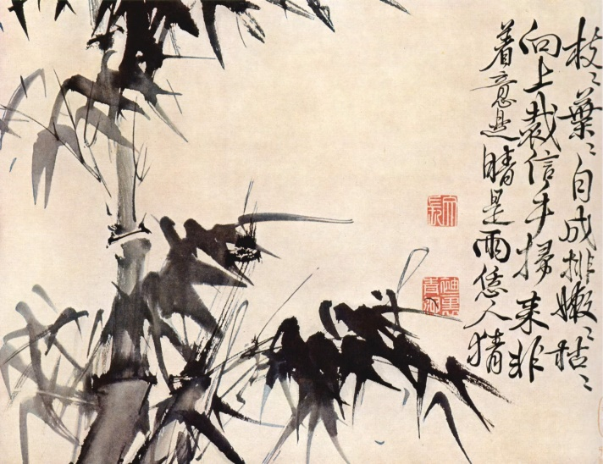the modern masters [Wu Changshuo](https://en.wikipedia.org/wiki/Wu_Changshuo) and [Qi Baishi](https://en.wikipedia.org/wiki/Qi_Baishi).[[2]](https://en.wikipedia.org/wiki/Xu_Wei#cite_note-Barnhart232-2)Qi once exclaimed in a poem that "How I wish to be born 300 years earlier so I could grind ink and prepare paper for Green Vine ( A Xu Wei pen name)" (恨不生三百年前，為青藤磨墨理紙). Xu Wei can be considered as the founder of modern painting in China. His influence continues to exert itself. Despite his posthumous recognition, Xu was manifestly mentally ill[[1]](https://en.wikipedia.org/wiki/Xu_Wei#cite_note-Cihai-1)and unsuccessful in life, ending his life in poverty after the murder of his third wife and several attempts at suicide.

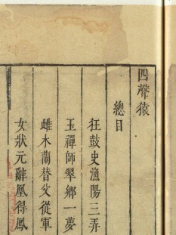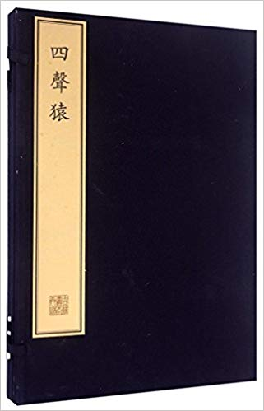***Relating to this Text***

Xu's [courtesy names](https://en.wikipedia.org/wiki/Courtesy_name) were Wenqing (文清) and then later Wenchang (文長).

Xu was a [playwright](https://en.wikipedia.org/wiki/Playwright) who wrote the following four plays, including *The Heroine Mulan Goes to War in Her Father's Place* (雌木蘭 *Ci Mulan*), in which he retold Mulan’s stories. He makes up her surname as Hua, and names of other members in her family.

***About HuangMuLan***

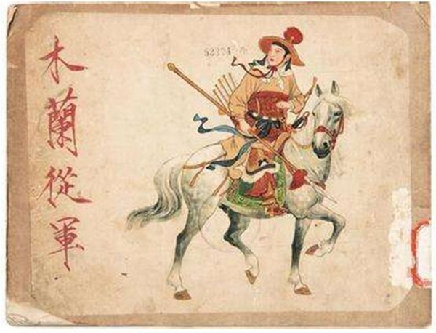**Hua Mulan** ([Chinese](https://en.wikipedia.org/wiki/Traditional_Chinese_characters): 花木蘭) is a legendary Chinese [woman warrior](https://en.wikipedia.org/wiki/Women_warriors_in_literature_and_culture) from the [Northern and Southern dynasties](https://en.wikipedia.org/wiki/Northern_and_Southern_dynasties) period (420–589) of Chinese history, originally described in the *Ballad of Mulan* ([Chinese](https://en.wikipedia.org/wiki/Traditional_Chinese_characters): 木蘭辭; [pinyin](https://en.wikipedia.org/wiki/Pinyin): *Mùlán cí*). In the ballad, Hua Mulan takes her aged father's place in the army. Mulan fought for twelve years and gained high merit, but she refused any reward and retired to her hometown.

The historic setting of Hua Mulan is in the [Northern Wei](https://en.wikipedia.org/wiki/Northern_Wei) (386–536). Over a thousand years later, [Xu Wei](https://en.wikipedia.org/wiki/Xu_Wei)'s play from the [Ming dynasty](https://en.wikipedia.org/wiki/Ming_dynasty) places her in the Northern Wei, whereas the [Qing dynasty](https://en.wikipedia.org/wiki/Qing_dynasty) *Sui Tang Romance* has her active around the founding of the [Tang](https://en.wikipedia.org/wiki/Tang_dynasty) c. 620. In 621, the founder of the Tang dynasty was victorious over [Wang Shichong](https://en.wikipedia.org/wiki/Wang_Shichong) and [Dou Jiande](https://en.wikipedia.org/wiki/Dou_Jiande), the latter was the father of Dou Xianniang, another female warrior who became Mulan's [laotong](https://en.wikipedia.org/wiki/Laotong) in the *Sui Tang Romance*.[[1]](https://en.wikipedia.org/wiki/Hua_Mulan#cite_note-1)

1. The *Ming* Dynasty (AD1368－1644). *XU* was born in 1521 in nowadays *ZheJiang* Province, and died in 1593.
2. George Washington, first President of the USA.